**SPRINT 2**

|  |  |
| --- | --- |
| DATE | 17 NOVEMBER 2022 |
| PROJECT ID | PNT2022TMID24781 |
| PROJECT NAME | SMART SOLUTION FOR RAILWAYS |

**PROCEDURE:**

**Step1**: Develop node red web application for train ticket booking .

**Step2**: Copy the node red link and add /UI to the same link and browse it.

**Step3**: Fill the details .

**Step4**: Click on submit.

**Step5**: QR code will be submitted.

**Step6**: Ticket is generated.

**NODE RED FLOW CONNECTION:**

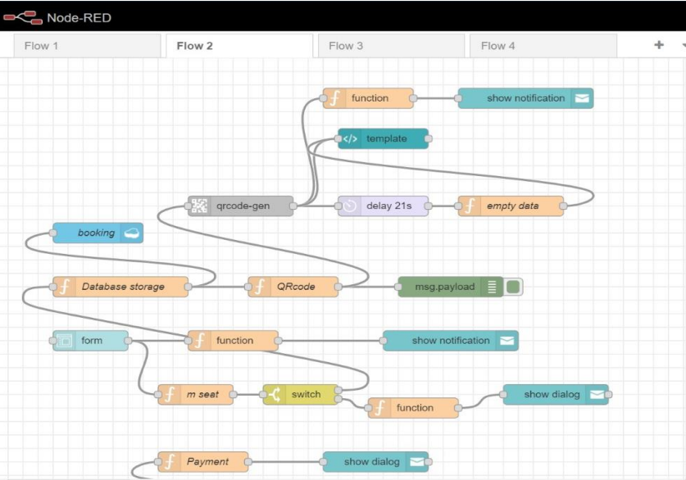

NODE RED FLOW FOR PAYMENT:

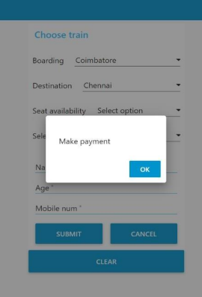

**QR CODE GENERATION:**

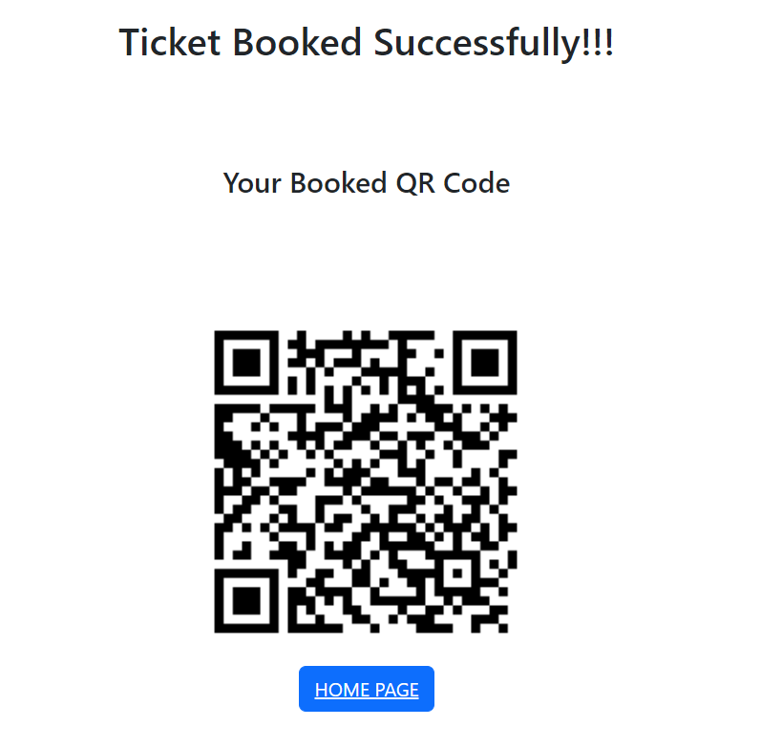

**NODE RED OUTPUT:**

